
a
Company
Logotype

Cone Beam Computed Tomography- Report



Porur Dental X-rays & CBCT

Patient Name : Mrs. Rajalakshmi | Date of Report : 17.07.2024
Age/ Gender : 51 years/ Female | Region of Interest : CBCT Sectional Maxilla
Referring doctor: Dr. V. Nethaji | Indication : Implant assessment
Clinical Notes: Nil
PATIENT INFORMATION

CBCT- Sectional Maxilla provided
CBCT – IMAGE DETAILS

RADIOGRAPHIC INTERPRETATION

- Completely missing crown and root portion in relation to 23, 24, 25, 26, 27, 28.
- The maxillary alveolar ridge is present with normal trabecular pattern.

IMPLANT ASSESSMENT

 | 23 region | 24 region
Sub-Crestal | 3.86 | 5.38
Mid- Crestal | 5.51 | 6.4
Distance between the alveolar ridge and Floor of the Nasal cavity (in mm) | 15.93 | 14.86

 | 25 region | 26 region | 27 region
Sub-Crestal (in mm) | 5.77 | 6.98 | 7.02
Mid- Crestal (in mm) | 7.36 | 7.89 | 8.84
Distance between the alveolar ridge and floor of the maxillary sinus (in mm) | 18.62 | 17.24 | 10.06

RADIOGRAPHIC IMPRESSION

- Partially edentulous maxillary arch.

Kindly correlate with clinical findings


IMAGES FOR REFERENCE

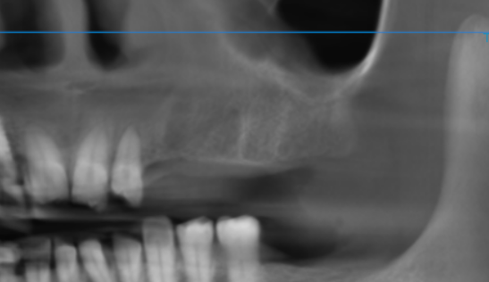

3-DIMENSIONAL VIEW
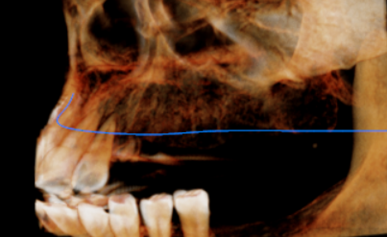

CROSS SECTIONAL VIEW

23 region | 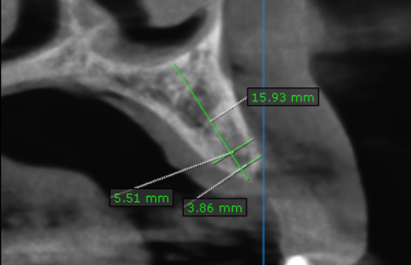
24 region | 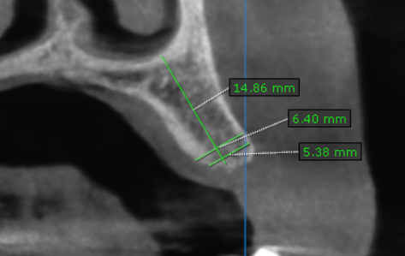
25 region | 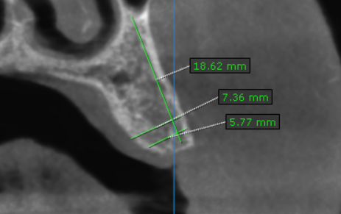
26 region | 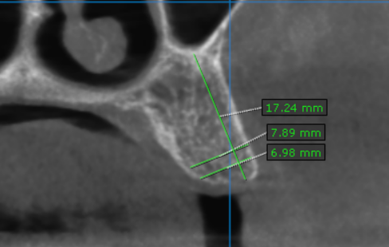
27 region | 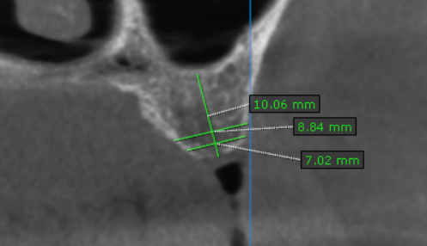

**** End of report ****

